  A. Anti-Oxidant Alkaline Water Filter Jug:  Removes sand, silt, rust, solids, residual chlorine, hardness, TDS and heavy metal. It is alkaline water and includes essential minerals. It has a negative ORP and small water molecule groups. Price is around USD$130.00 | 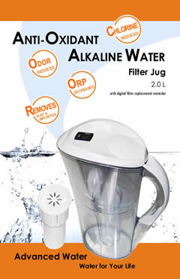
B.RO Purified Unit (1st Generation RO Unit):  RO purified, removes sand, silt, rust, solids, residual chlorine, hardness, TDS and heavy metal. It is acidic water, and it has a positive ORP and large water molecule groups. Price is around USD$350.00  This RO purified unit’s RO membrane is High Recovery Membrane (1 permeate water : 1 waste water). | 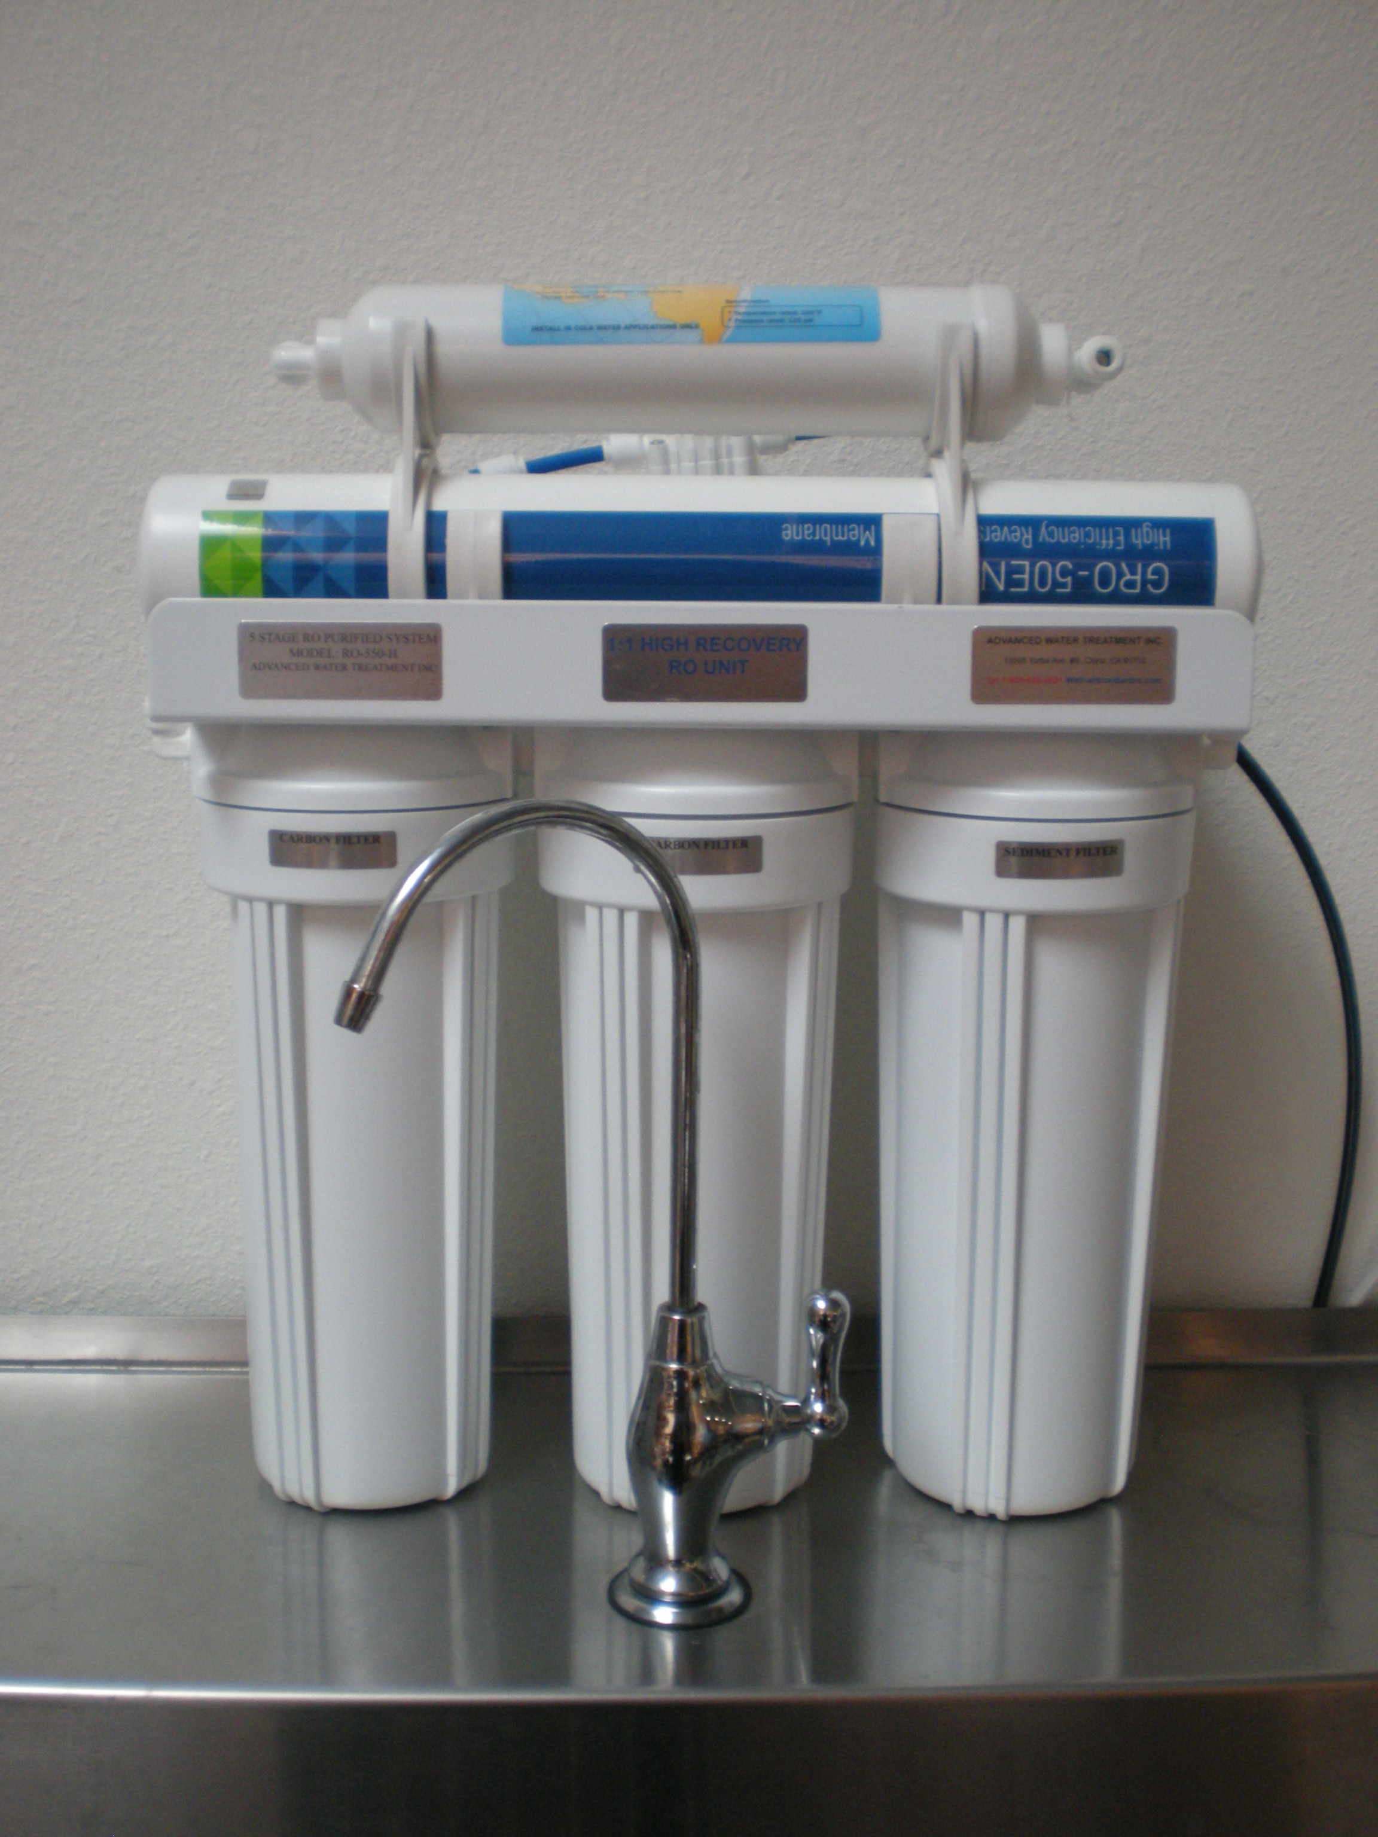
C .Alkaline RO Purified Unit (2nd Generation Unit):  RO purified, removes sand, silt, rust, solids, residual chlorine, hardness, TDS and heavy metal. It is alkaline water and includes essential minerals. It has a positive ORP and large water molecule groups. Price is around USD$499.00.  This RO purified unit’s RO membrane is High Recovery Membrane (1 permeate water : 1 waste water). | 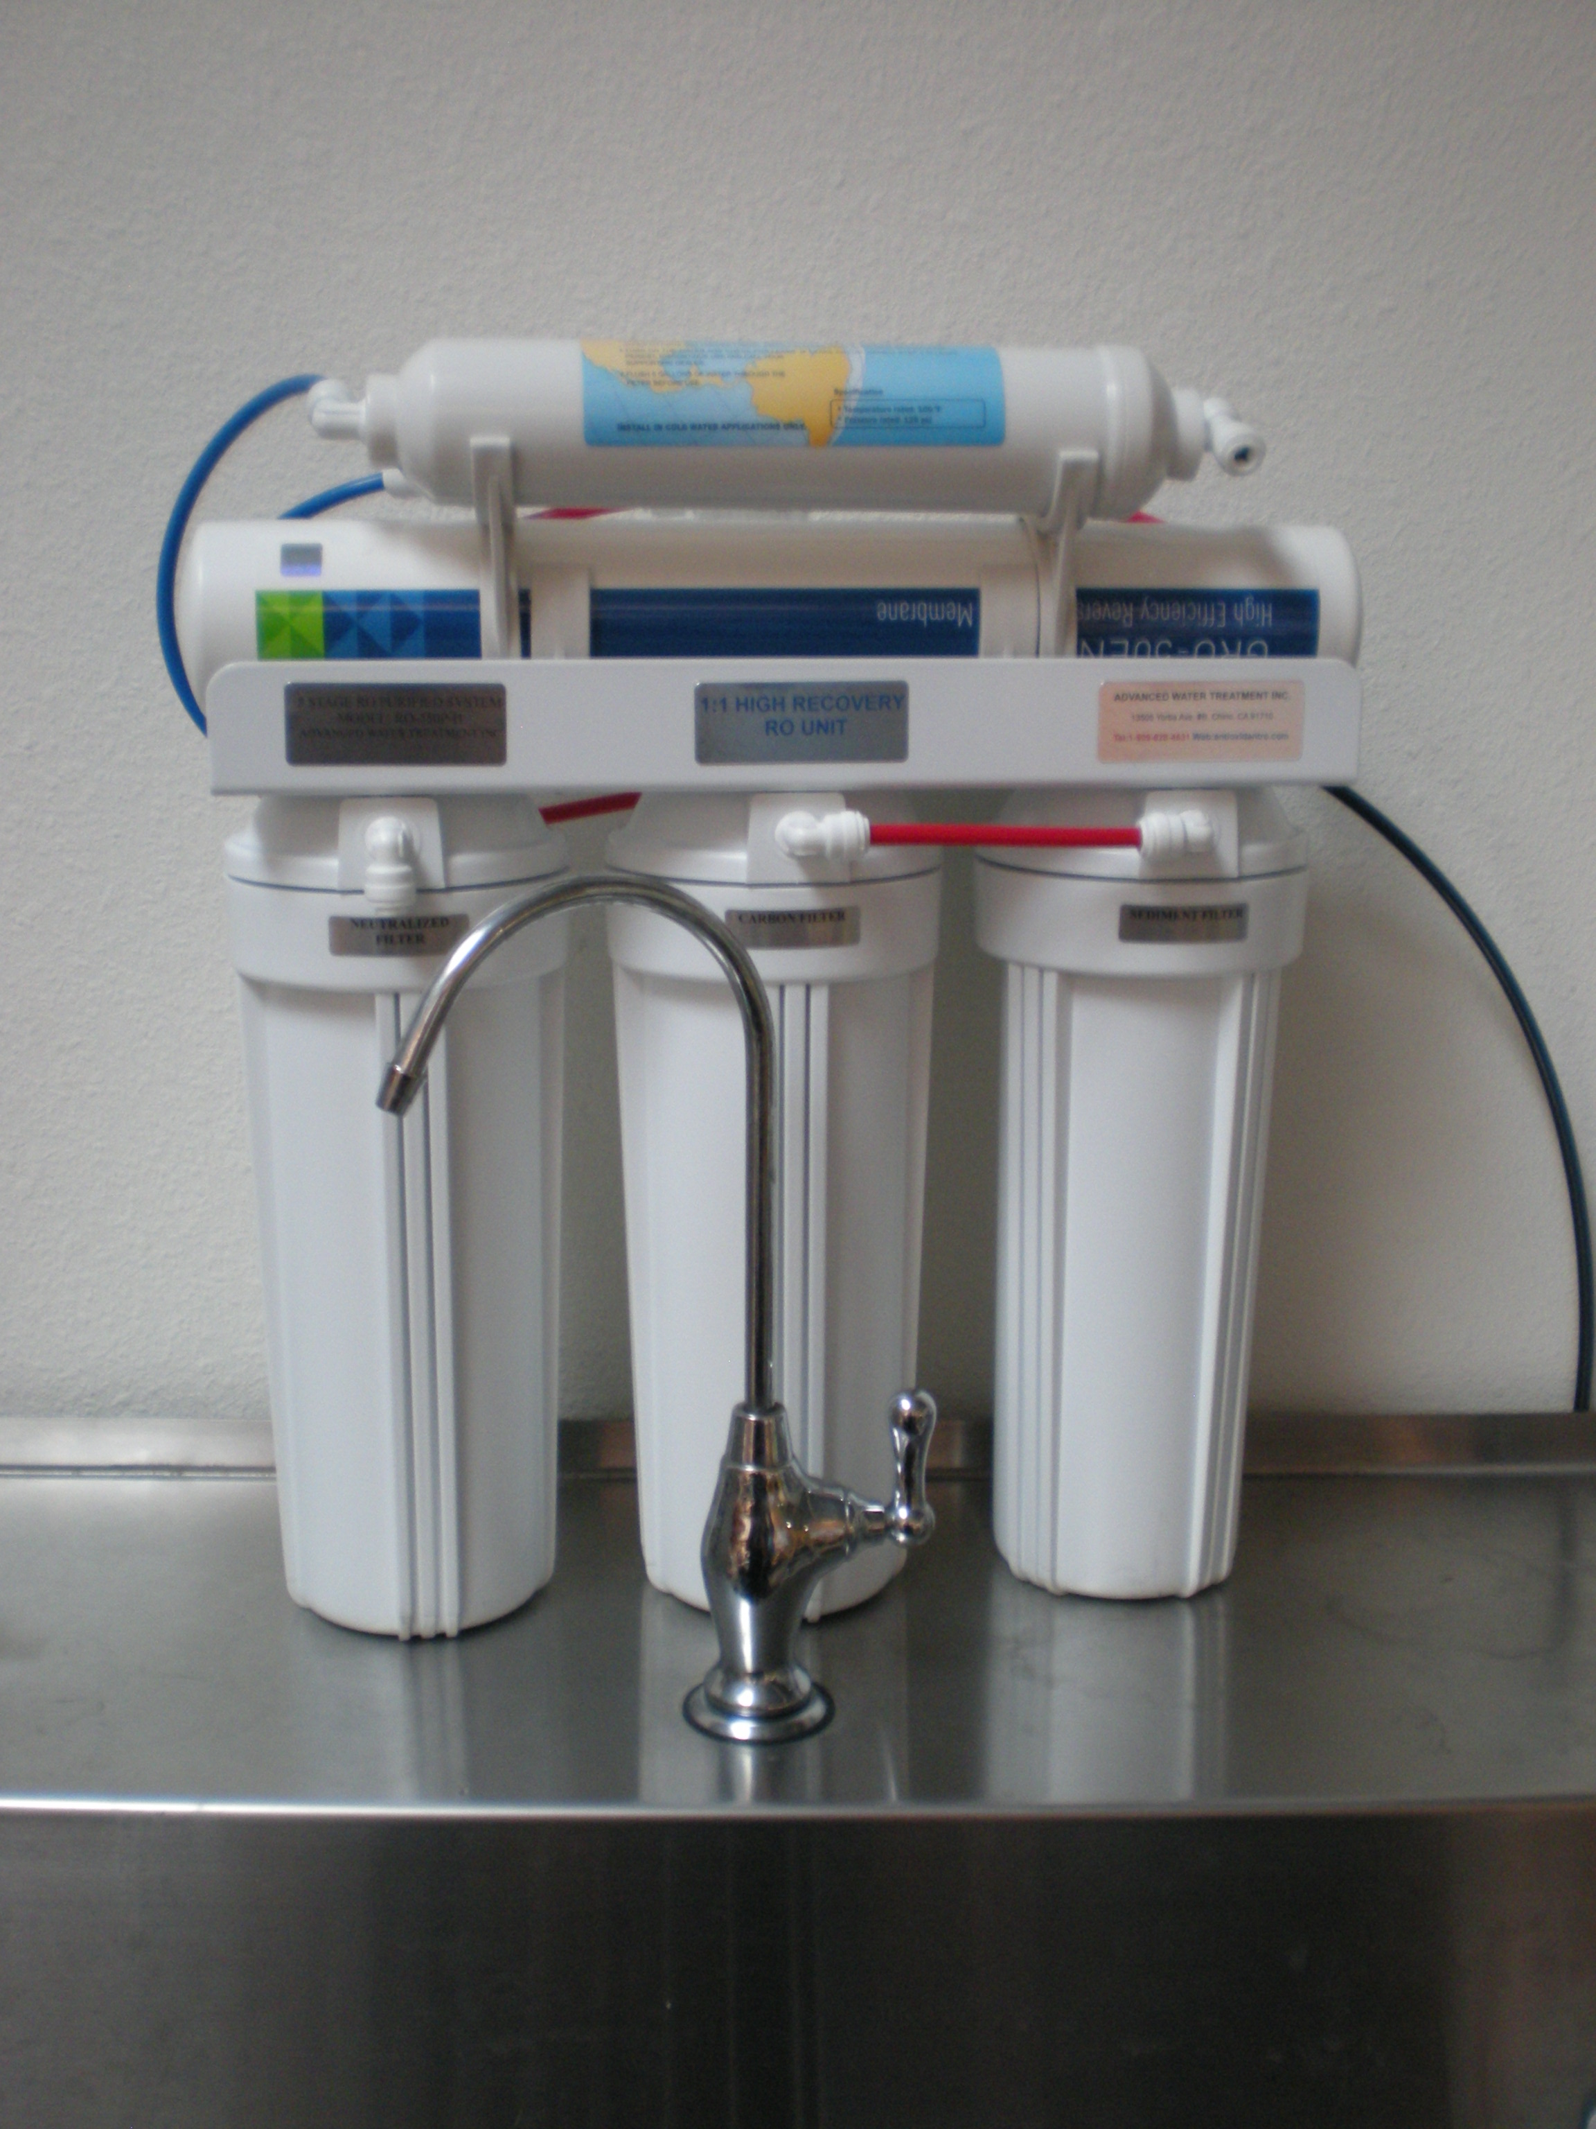
D Specialty RO Unit (3rd Generation RO Unit) + Water Electrolysis Unit:  Removes sand, silt, rust, solids, residual chlorine, hardness, TDS and heavy metal. It is alkaline water and includes essential minerals. It has a negative ORP and small water molecule groups. Price is around USD$2,999.00.  This RO purified unit’s RO membrane is High Recovery Membrane (1 permeate water : 1 waste water). | 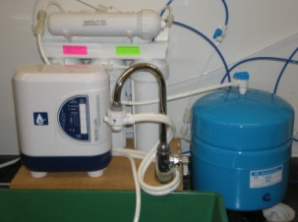
E Anti-Oxidant Alkaline RO Purified Unit (4th Generation RO Unit):  Removes sand, silt, rust, solids, residual chlorine, hardness, TDS and heavy metal. It is alkaline water and includes essential minerals. It has a negative ORP and small water molecule groups. Price is around USD$1,299.00.  This RO purified unit’s RO membrane is High Recovery Membrane (1 permeate water : 1 waste water). | 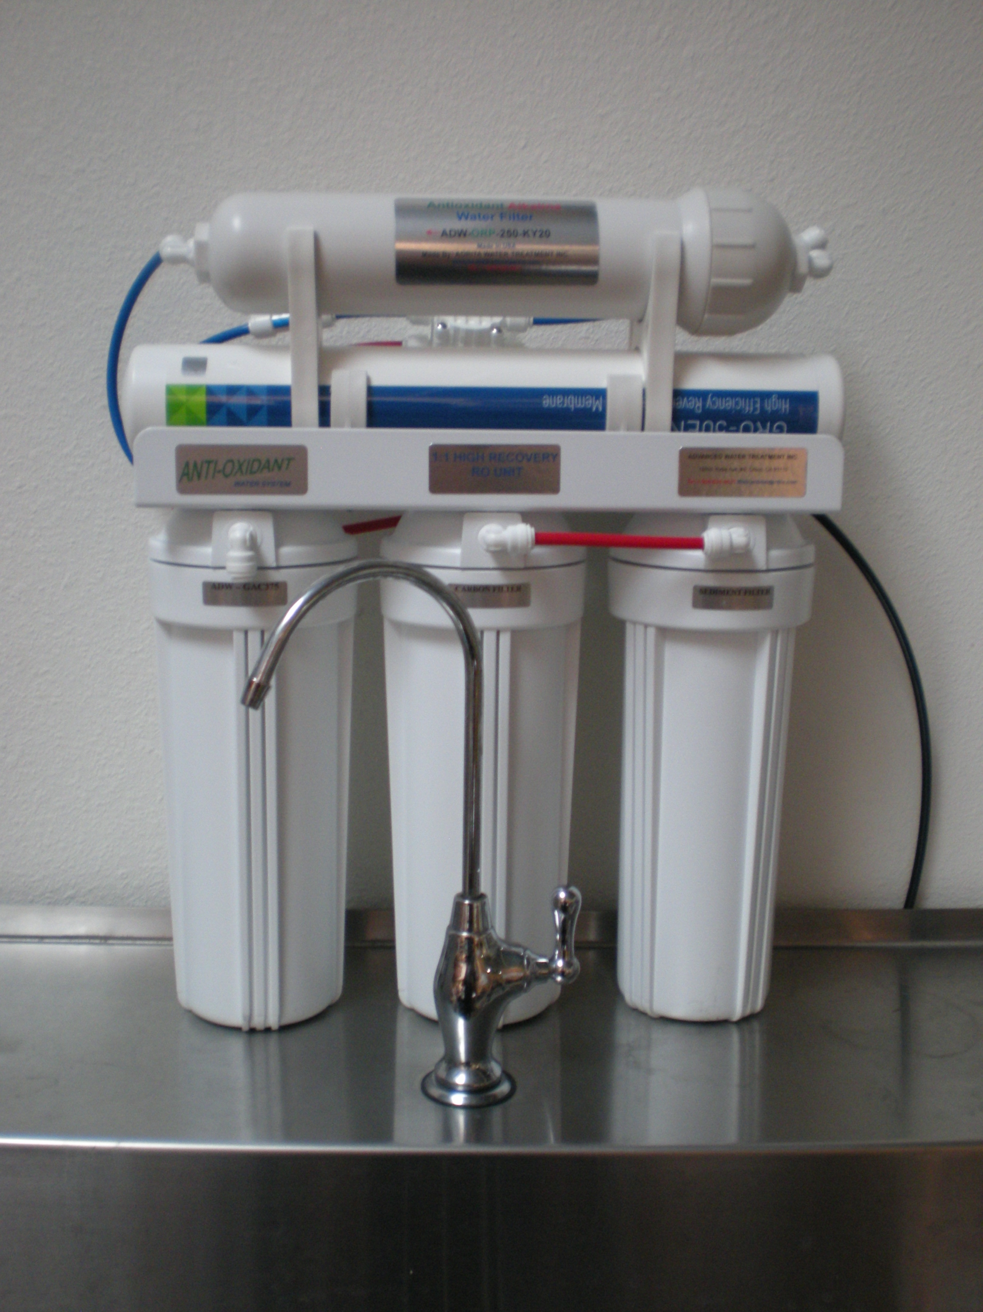
F. ARWT-HT HYDROGEN WATER MAKER  Portable and rechargeable hydrogen water maker. Inside with minerals filter cartridge. The Hydrogen water can electronic pure water or the bottled water to hydrogen-rich (up to 1200 ppb), negative ORP (up to -450 mv). Alkaline contain essential minerals antioxidant hydrogen water. This water maker can be used to high temperature water (up to 99℃) | 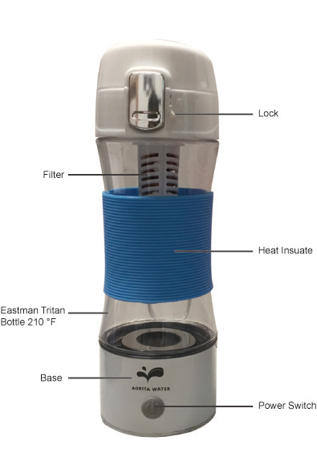
ADW-8300

